

Marketplace - Fiverr

Profile Name - Code_craf|| Shovon

Project Name - Sixtine AI Website

Client Name - Martin

Language - English

Country - Switzerland 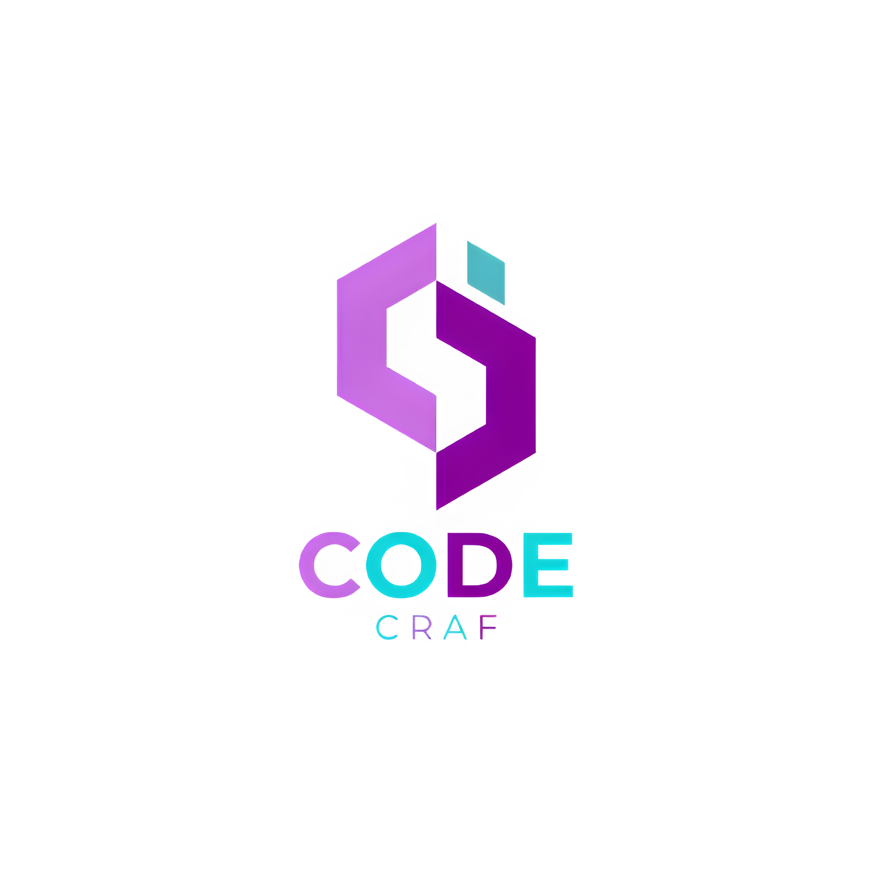

**Table Of Contents** 5 (499) 

**Fiverr Choice**

**Project Overview 3**

**Purpose of the project 3**

**Feature list 4**

**Scope of Work** 6

- UI/UX Design 6

- Frontend Development 6

- Backend & AI Development 6

- Testing & Deployment 6

**Additional cost 7  
Support & maintenance 7**

**Security measurement 8**

**You have to provide 8**

**Deliverable 9**

**Ownership 9**

**Payment by Milestones: 10**

#### 

#### 

#### 

#### **Project Overview**

This project involves rebuilding the demo platform from scratch while maintaining the same design references and core functionalities. The system will feature three main modules: document upload with OCR and summarization, audio recording with medical report generation, and an AI chat assistant for querying patient data. Secure user roles will be established for admins, Doctors, and Medical Assistants, enabling role-based access and control. All patient data and records will be integrated into a structured database, ensuring easy retrieval and secure management. The first phase will focus on replicating the demo with full documentation, while future phases will expand with scheduling, ERP features, and translation. Once complete, the platform will be deployed on the client’s server, with full ownership and 3 months of free maintenance support.

# 

# **Purpose of the Project**

The purpose of this project is to replicate and enhance the existing medical AI demo platform into a secure, fully documented, and production-ready solution. It aims to provide doctors with an intelligent assistant that simplifies patient data access, medical document processing, and consultation workflows. By integrating OCR, audio transcription, and AI-powered chat, the system will reduce time spent on repetitive tasks while improving accuracy in patient management.  
 The platform will empower healthcare professionals to make faster and more informed decisions, increasing efficiency in daily clinical practice.  
 Additionally, it ensures scalability for future modules such as appointment scheduling, ERP integration, and multi-language support.  
 Overall, the project’s purpose is to deliver a robust foundation for AI-driven healthcare tools that can be expanded over time.

# **Technology:**

* UX/UI for the website and Admin Dashboard
* Frontend development of your website using Next.js || React.js for the admin panel.
* Backend development (Django | PostgreSQL as a Database)
* AI development with Python.
* QA Testing with our Engineer.
* I will deploy your website and app on your server.

# 

# 

# **Features List**

### 

**User Roles & Authentication** – Secure login for Admin, Doctors, and Medical Assistants with role-based access.

**Patient Management** – Create, manage, and view patient profiles with associated medical history.

**Document Upload & OCR** – Drag-and-drop medical PDFs for automatic text extraction and analysis.

**Medical Report Summarization** – Generate structured summaries of uploaded medical documents.

**Audio Recording & Transcription** – Record doctor–patient conversations and convert them into structured reports.

**AI Chat Assistant** – GPT-powered chat to query patient data, documents, and health updates.

**Database Integration** – Patient data and medical records stored in a secure, centralized database.

**Multi-language Support** – Base system in French, with future integration of translation to English.

**Doctor Consultation Tools** – Doctors can review patient data, interact via AI chat, and prepare prescriptions.

**Future Calendar & Scheduling** – Planned module for appointment management and doctor schedules.

**ERP Expansion (Future)** – Roadmap for integrating billing, advanced reporting, and extended medical workflows.

**System Documentation** – Full technical documentation for developers, covering architecture, APIs, and workflows.

**Deployment & Ownership** – Full system rebuilt from scratch, deployed to client’s server, with complete code ownership.

**Free Maintenance** – 3 months of post-launch maintenance and bug fixes included.

# 

# 

# **Price, Timeline & Technology of this Project**

| **Step** | **Task** | **Technology** | **Time** | **Price** |
| --- | --- | --- | --- | --- |
| **1st Phase** | UI/UX Design for website and Admin Panel | Figma tools for the UI design | **15 days** | **$1,400 ( USD)** |
| **2nd Phase** | Frontend Development  Website and Admin Dashboard | Next.js for Website & React.js for Admin Dashboard | **15 Days** | **$1,200 (USD)** |
|
|
| **3rd Phase** | API Integration & Backend Development || AI Training | Python ||  Django |  PostgreSQL as a Database | **15 Days** | **$1,200 (USD)** |
|
| **4th Phase** | Deployment & Testing | QA Testing | As per policy | **$200 (USD)** |
| **Total timeline & Price :** | | | **45 Days** | **$4,000 (USD)** |

Total Cost: |$4,000 USD|

Total Timeline: | 45 days |

**Support & Maintenance**

We believe in providing a one-stop solution to our clients. After the development is completed, we will let you test the platform thoroughly. After we get the final version of the platform, we will deploy or publish it. We will provide you with free post-project support for bug fixing for 3 months after the system goes live.

**We will provide you with free post-project support for bug fixing for 3 months after the platform goes live.**

# 

# 

# 

# **Security Measures:**

# ● JWT Authentication

# ● Data Encryption

# ● Secure API Communication

# ● Regular Security Audits

# ● Security measures (JSON Web Token, encryption)

**YOU HAVE TO PROVIDE:**

* Your color preference
* All necessary APIs
* Data sources
* All necessary credentials

# 

# **Deliverable:**

* User-friendly and Unique UI design
* UI/UX design with Prototype
* Source Code for the frontend.
* Source Code for the backend.
* All the Source Code of your project.

**Ownership:**

At the end of the project, the source code will be sent to the client, and the client will have ownership and rights to the source code and the full project.

# 

# Payment by Milestones:

Milestone 1: UI Design

* Develop the design of the website and admin dashboards with a focus on a seamless, user-friendly experience and an intuitive interface.

Milestone 2: Design Implementation

* Build the frontend of the website, precisely adhering to the design principles and ensuring responsiveness and cross-browser compatibility.

Milestone 3: Backend Development & API Integration

* Develop the backend architecture, ensuring alignment with the approved design specifications and project goals.
* Integrate APIs for the admin panel to enable smooth functionality and communication between all components.

AI Development & Training

* Develop and train AI models using preprocessed datasets for the required functionalities
* Ensuring seamless backend integration and real-time functionality.

Milestone 4: Testing and Deployment

* Thoroughly test and deploy on your domain, hosting, and website

Kind Regards,  
 Shovon